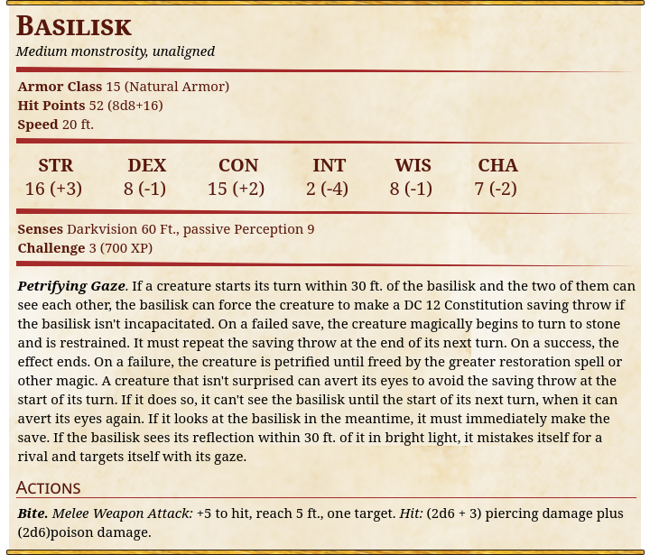
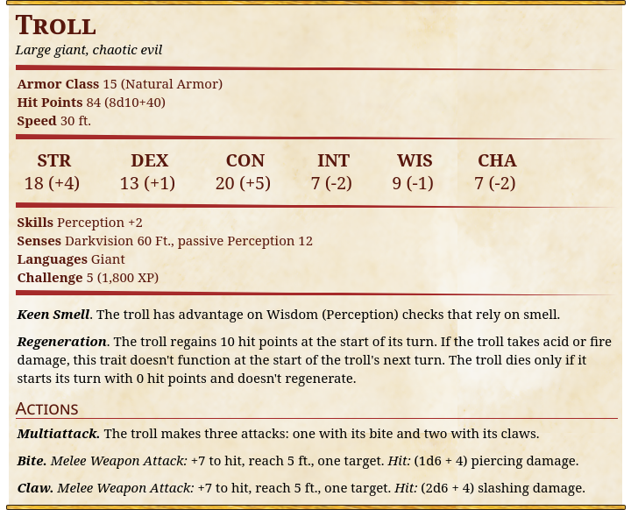
Party will fight two Basilisks and two trolls with the attached stat blocks

The trolls and basilisks will be sentient creations of Azetoph’s but are currently attacking both Zephyr and Drazhomir

